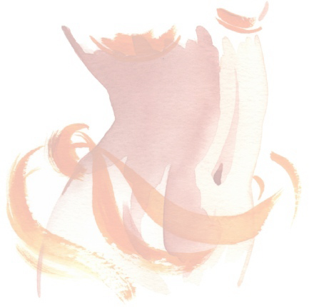
PrimeAesthetica.com
Dr. Ghiath Kashlan – Medical Director

About Sclerotherapy/Laser Treatment for Spider Veins
Spider veins - known in the medical world as telangiectasias - are small, thin veins that lie close to the surface of the skin. Although these super-fine veins are connected with the larger venous system, they are not an essential part of it. Spider veins usually take on one of three basic patterns. They may appear in a true spider shape with a group of veins radiating outward from a dark central point; they may resemble tiny branch-like shapes; or they may appear as thin separate lines. A number of factors contribute to the development of spider veins, including heredity, pregnancy and other events that cause hormonal shifts, weight gain, occupations or activities that require prolonged sitting or standing, and the use of certain medications.

Spider veins are more common in women than men. Men and women of any age may be good candidates for Sclerotherapy/Laser treatments, but most fall in the 30-to-60 category. Spider veins may become noticeable very early on - in the teen years. For others, the veins may not become obvious until they reach their 40s.

Sclerotherapy is the method for eliminating superficial telangiectasias (spider veins) by the injection of a sclerosing agent into the veins. The majority of most patients will have a significant clearing of the veins. However, there can be no guarantee that it will be effective in every case

Polidocanol is the sclerosing agent that will be used in our Sclerotherapy procedures. Polidocanol is a European drug not yet approved by FDA. We chose to use this agent in our Sclerotherapy procedures because it is believed by many vein specialists to be the safest sclerosing agent with the least amount of side effects.

Laser treatment for Spider Veins
Laser therapy involves directing the laser over the specific vein to be treated, the beam is then heated, resulting in destruction of the vein walls. There is usually minimal reaction after the laser therapy. After the treatment a compression bandage or hose is worn up to 2 weeks. Laser therapy is often used in conjunction with sclerotherapy for the treatment of varicose and spider veins.
It is very important to realize that Sclerotherapy/Laser treatments do not prevent the development of new spider veins and varicosities later in life. Many people require treatments from time to time to keep their legs clear. The total number of treatments depends upon the amount and the severity of the veins (average is 3-5 but can take more than 10 in severe cases). In each session multiple areas can be treated. Each vein may need to be injected several times, in order to clear or improve the condition. Improvement is usually seen in a period of months.

If you are pregnant or breastfeeding, you may be advised to postpone Sclerotherapy/Laser treatment. In most cases, spider veins that surface during pregnancy will disappear on their own within three months after the baby is born. Also, because it's not known how sclerosing solutions may affect breast milk, nursing mothers are usually advised to wait until after they have stopped breastfeeding.

Compression Stockings are used with the Sclerotherapy procedure in order to produce better results. We use Sigvaris stockings with 30-40 compression. These can also be worn to help prevent or slow the progression of vein conditions later in life.

Sclerotherapy/Laser treatments are usually considered cosmetic and are not covered by insurance companies.

Risks associated with Laser/Sclerotherapy may include: Pain, burning, blister formation, and stinging sensation at the treatment site; infection, scar formation and pigment (color) changes at the treatment site; hyper pigmentation (increase in skin color or darkening), poor cosmetic outcome, reoccurrence of vessels at the treated site, allergic reaction, superficial clot formation, bleeding, matting, bruising, ulcer formation and or temporary phlebitis at the treatment site.

RECOMMENDATIONS FOR BETTER LEGS

REGULAR EXERCISE

Walking, running, stairmaster, aerobics, swimming, elliptical machine, or biking for 30 minutes, 5-7 days per week will help reduce aching, pain and tiredness in your legs.

ELEVATE YOUR LEGS

Elevating your legs above heart level for at least 10 minutes once or twice daily may diminish aching and swelling.

MOVE YOUR LEGS FREQUENTLY

Flexing your ankles 10 times will pump the blood out of your legs like walking does. Repeat this every 10 minutes while standing or sitting and try to walk for at least 2 minutes every half hour.

AVOID WEARING HIGH HEELS

Wearing high heels interferes with the normal pumping action that occurs when you walk and may lead to aching and cramping of the legs.

MAINTAIN A PROPER WEIGHT

Even moderate weight loss may reduce aching in the legs due to varicose veins and diminish the rate at which spider veins develop.

WEAR SUPPORT HOSE

Support hose is available at pharmacies and medical supply stores. There are many brands to choose from. Lighter support stockings are available at department stores. However, it is best to wear a stocking that is labeled "graduated" as this will really help to improve your vein function.

Light support: 4-14 mm

Moderate support : 15-20 mm

Heavy support : 20-30 mm

Prescription strength: 30-40 mm or above

